**Theory&Concept**

**Objective:-ToimplementtheconceptofgroupingofData. Grouping Data From Tables:**

There are circumstances where we would like to applythe aggregate function notonlyto asingle set oftuples, but also to agroup ofsetsoftuples, we specify this wish in SQL using the group byclause. The attribute or attributes given in the group by clause are used to form group. Tuples with the same value on all attributes in the group by clause are placed in one group.

**Syntax:**

SELECTcolumnname,columnname FROMtablename

GROUPBYcolumnname;

At times it is useful to state a condition that applies to groups rather than to tuples. For example we might be interestedinonlythosebrancheswheretheaverageaccount balance is morethan1200. This condition does not apply to a single tuple, rather it applies to each group constructed bythe GROUP BYclause. To expresssuchQuestionry, weusethehaving clauseofSQL. SQLappliespredicates in the having may be used.

**Syntax:**

SELECTcolumnname,columnname FROMtablename

GROUPBYcolumnname; HAVINGsearchcondition;

**EXPERIMENTNO.7**

**Objective-Answerthefollowing Queries:**

Q1.-Printthedescriptionandtotalquantitysold foreachproduct.

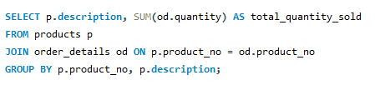

Q2.- Find the value of each product sold.

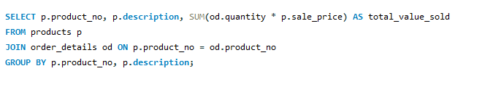

Q3.-Calculatetheaveragequantitysold foreachclientthat hasa maximumordervalueof 15000.

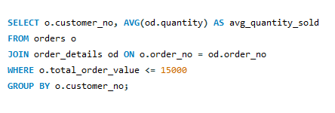

Q4.-FindouttheproductswhichhasbeensoldtoIvan.

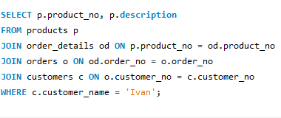

Q5.- Find the names of clients who have ‘CD Drive’.

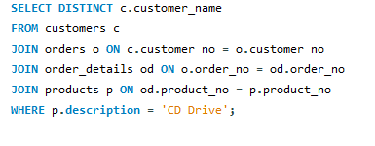

Q6.-Findtheproductsandtheirquantitiesfortheordersplacedby‘Vandana’ and‘Ivan’.

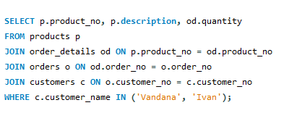

Q7.- Select product_no, total qty_ordered for each product.

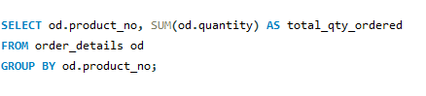

Q8.-Select product_no,productdescriptionandqtyorderedforeachproduct.

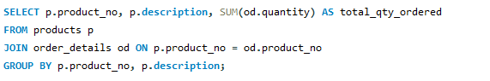

Q9.- Display the order number and day on which clients placed their order.

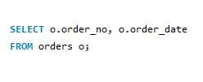

Q10.-DisplaythemonthandDatewhentheordermustbedelivered.

